Binary Tree Child Identification
Introduction
The Binary Tree Child Identification System using C++ is a program designed to identify the child nodes, parent node, and depth of a selected node in a binary tree. A binary tree is a non-linear data structure in which each node can have at most two children: a left child and a right child.
The program searches for a specified node and determines whether it has a left child, a right child, both children, or no children. It also displays the parent and depth of the selected node. The program handles missing nodes and empty trees and allows the user to check multiple nodes in a single execution. This project helps in understanding binary tree structures, recursion, pointers, searching, and tree traversal techniques in C++.

Problem statement
Write a C++ program to identify the children of a specified node in a binary tree. The program should determine whether the selected node has a left child, a right child, both children, or no children. It should also display the parent node and depth of the selected node. The program must handle cases where the specified node is missing or the binary tree is empty. Additionally, it should allow the user to repeat the query for multiple nodes during a single execution.
Algorithm
- Start the program.
- Initialize the binary tree.
- Check whether the binary tree is empty. If it is empty, display a message and stop the search.
- Ask the user to enter the value of the node to be identified.
- Search for the specified node in the binary tree.
- If the node is not found, display “Node not found.”
- If the node is found, identify and display its parent node and depth.
- Check the left and right child pointers of the selected node.
- Display whether the node has both children, only a left child, only a right child, or no children.
- Ask the user whether they want to check another node.
- If the user chooses yes, repeat the search from Step 4; otherwise, continue.
- Stop the program

Flowchart:-

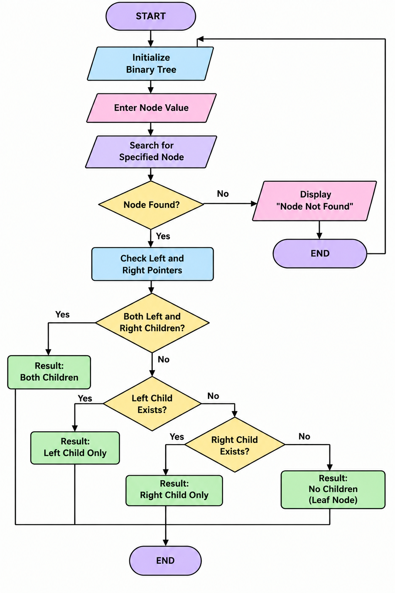
Conclusion
The Binary Tree Child Identification System was developed using C++ to analyze the relationships between nodes in a binary tree. The program identifies the left and right children of a selected node and displays its parent and depth. It also handles empty trees and missing nodes and supports multiple queries in one execution. This project improves understanding of binary tree operations, recursion, pointers, node relationships, and tree traversal techniques.

